
Cabra 0.7.0 User Manual

Table of Contents
1 Overview 5
About this manual 5
Conventions used in this manual 5
Feedback 5
Copyright 5
Computer requirements 6
Windows 6
Mac 6
Installing Java Runtime Environment (JRE) 6
2 Cabra Basics 7
About Cabra 7
Features 7
3 Installing and Using Cabra 8
Installing Cabra 8
To install the program on Windows or Mac 8
Using Cabra 8
To open the program 8
To check for program updates 8
To exit the program on Windows or Mac 9
Uninstalling Cabra 9
To uninstall the program on Windows or Mac 9
4 Working with a Project 10
What is a project? 10
To change the stored projects location 10
To load projects from a new folder 10
Creating and using a project 10
To create a new project 10
To open an existing project 11
To change the project’s font and size 11
To rename a project 11
To delete a project 11
Importing and exporting a project 12
To download a project from hathix.com 12
To import a project 12
To export a project 12
To upload a project to hathix.com 12
Creating, editing, or deleting a project note 13
To create a project note 13
To change note font styles and colors 13
To add a picture to a note 13
To delete a project note 14
5 Managing Flashcards 15
What are flashcards? 15
Creating flashcards 15
To create a flashcard 15
To close the Flashcard Creation window 16
Using the Card Manager 16
To edit a flashcard 16
To delete a flashcard 17
6 Studying with Flashcards 18
What is a study session? 18
To start a study session 18
To skip a flashcard 18
To quit a study session 18
To change the number of flashcards shown during each study session 18
Understanding your Study Session Results 19
About your Study Session Results 19
To close the Study Session Results window 19
Earning a higher project rank 19
Resetting the deck 19
To reset the deck of flashcards 20
Studying with printed flashcards 20
To print flashcards 20
To prepare printed flashcards 20
7 Personalizing Cabra 22
Why personalize Cabra? 22
Themes 22
To change the theme 22
Earning points 22
To earn points 22
To redeem a code 23
To view a redeemed code 23
To purchase prize packs 23
To view your vault 24
8 Troubleshooting 25
Common problems 25
To clear program data 25
Technical support 25
9 Appendix 26
Keyboard shortcuts 26
10 Index 27

Table of Figures

Figure 1: Cabra Interface 7
Figure 2: Download Web Page 8
Figure 3: Project Column 11
Figure 4: Flashcard Creation Window 15
Figure 5: Card Manager 16
Figure 6: Study Session Results Window 19
Figure 7: Printed Flashcards 21
Figure 8: How to Earn Points 23
Figure 9: Vault 24

Overview

About this manual
This manual will show you how to use the Cabra 0.7.0 program to create and use electronic flashcards so you can study faster and more effectively. Cabra is quick and easy to learn so you can start studying for your next test or assignment right away.

Conventions used in this manual
Bold, italic, 11 pt. Cambria font | Used to point out program elements such as buttons or tabs.  Example: Click Card Manager to review your flashcards.
Delete | Refers to the Delete, Del, or Backspace key on your keyboard.
Enter | Refers to the Enter or Return key on your keyboard.
 | This picture is shown next to a note. A note will give you additional information about the program.
 | This picture is shown next to a tip. A tip will give you a hint about using the program more effectively.
 | This picture is shown next to a warning. A warning will tell you something you shouldn’t do with the program unless you are absolutely sure.

Feedback
If you have questions about the program, please contact neel@hathix.com. If you have questions about this user manual, please contact Jennifer Honeycutt.

Copyright
©2012 Hathix.com. All rights reserved. Other company and product names mentioned herein may be trademarks of their respective companies. Mention of third-party products is for informational purposes only and constitutes neither an endorsement nor a recommendation. Hathix.com assumes no responsibility with regard to the performance or use of these products. All understandings, agreements, or warranties, if any, take place directly between the vendors and the prospective users. Every effort has been made to ensure that the information in this manual is accurate. Hathix.com is not responsible for printing or clerical errors.

Computer requirements
These are the minimum requirements needed to install and use Cabra 0.7.0.

Windows
Disk space | Minimum of 200 MB
Memory | Minimum of 128 MB
Processor speed | At least a Pentium 2 266 MHz processor running Windows XP, Vista, or 7
Administrator privileges | Yes
Java Runtime Environment (JRE) | Yes

Mac
Disk space | Minimum of 200 MB
Memory | Minimum of 128 MB
Processor speed | Any Intel-based Mac running Mac OS X 10.7.3 or later
Administrator privileges | Yes
Java Runtime Environment (JRE) | Yes

Installing Java Runtime Environment (JRE)
Many computers will have JRE pre-installed. If yours doesn’t, you won’t be able to use Cabra until you install it.

- Visit the Java Runtime Environment Download page at http://www.oracle.com/technetwork/java/javase/downloads/java-se-jre-7-download-432155.html.
- Accept the license agreement.
- Choose the correct download file:

Windows 32-bit system | jre-7u9-windows-i586.exe
Windows 64-bit system | jre-7u9-windows-x64.exe
Mac | jre-7u9-macosx-x64.dmg

- When the download is finished, double-click on the file on your computer and follow the installation instructions.

Cabra Basics

About Cabra
Cabra is a free, award-winning studying program (Figure 1). You can create and study flashcards with Cabra to ace your next test, learn a new language, or prepare for a homework assignment.

Figure 1: Cabra Interface
Menu Bar
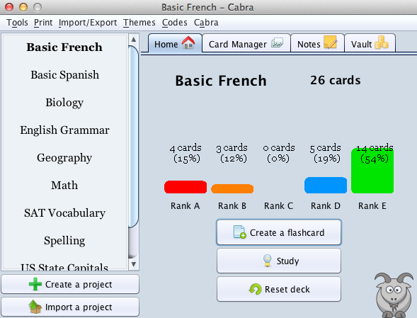
Flashcard Actions
Project Actions
Project Rankings
Project Column
Active Project
Project Tabs

Features
Create flashcards | Write project notes
Create flashcards (with images, if you like) and study them at your own pace. Cabra's advanced algorithm schedules personalized and effective studying sessions for you. | Jot down your thoughts or class notes using the integrated Notes feature. You can add images or highlighting to help you remember the most important information.
Print and share | Dress up Cabra
Create flashcards on any subject imaginable, print them, and share them with your friends. | Dress up your Cabra with over a dozen colorful themes.
Save your wallet | Save the earth
Cabra is, and always will be, free. After all, the best things in life are free. | Stop using wasteful paper note cards and use Cabra for all your flashcard needs.
Become a whiz | Empower your brain
Cabra packs a lot of power, but it has a clean, intuitive interface and is very easy to use. You don't have to be a whiz to use Cabra, though Cabra could make you into one. | Cabra uses the powerful Leitnerian algorithm when you're studying, ensuring you get the most studying done in the least amount of time.

Installing and Using Cabra

Installing Cabra

To install the program on Windows or Mac

You must have Java Runtime Environment installed on your computer to proceed. Please see Installing Java Runtime Environment (JRE) for instructions.

- Visit the Cabra download Web page at http://cabra.hathix.com/download (Figure 2).
- Click Cabra for anyone.
You’ll be taken to another Web page, where your download will start within a few seconds.

- Click Save to download the Cabra 0.7.0.jar file.

Figure 2: Download Web Page
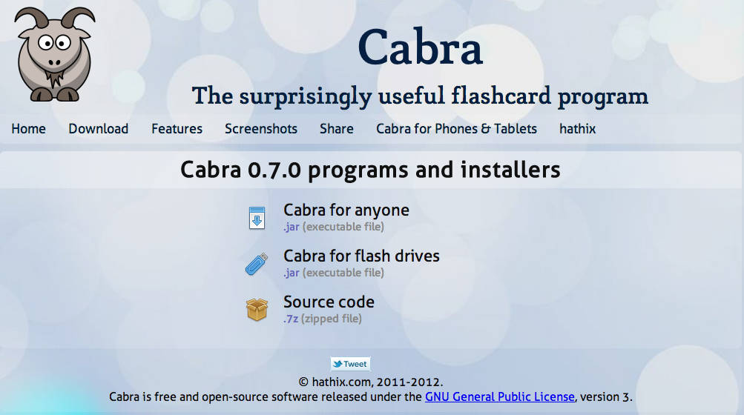

Using Cabra

To open the program
After you’ve installed Cabra, it’s time to start studying.

- Navigate to the location on your computer where you saved the Cabra 0.7.0.jar file.
- Double-click the file to open the program.

To check for program updates
From the Menu Bar, click Cabra > Check for updates.

When you check for updates, you may receive a code that you can redeem to earn points. See Earning points for more information.

To set the number of days between program update checks
The default is seven days, but you can change this to any number between one and 31.

- From the Menu Bar, click Tools > Settings > General.
- Use the arrows to select the number of days.
- Click the X in the top corner to close the Settings window.

To exit the program on Windows or Mac
Click the X in the top corner to close the program.

Uninstalling Cabra

To uninstall the program on Windows or Mac
- Exit Cabra if you have the program open.
- Drag the Cabra 0.7.0.jar file to the Recycle Bin on Windows or the Trash on Mac.

Working with a Project

What is a project?
A project is a collection of flashcards about one subject. For example, if you have an upcoming test on the U.S. capitals, you can create a project that contains a deck of 50 flashcards, one for each state capital.

To change the stored projects location
You may want to change the default location, depending on how your computer is set up.

- From the Menu Bar, click Tools > Settings > Project Location.
- Click Move projects to new folder.
- Select a new folder from your computer hard drive.
- Click Select.
- Click the X in the top corner to close the Settings window.

To load projects from a new folder
If you’ve saved projects in a folder other than the default folder, you can still open them in Cabra.

- From the Menu Bar, click Tools > Settings > Project Location.
- Click Load projects from new folder.
- Choose a folder and click Select.
- Click the X in the top corner to close the Settings window.

Creating and using a project

To create a new project
You’ll create a new project for every subject you want to study.

- Click Create a project.
- Type the name of the new project.
- Click OK.

Project names are listed in alphabetical order in the Project Column (Figure 3 on page 11).
Figure 3: Project Column
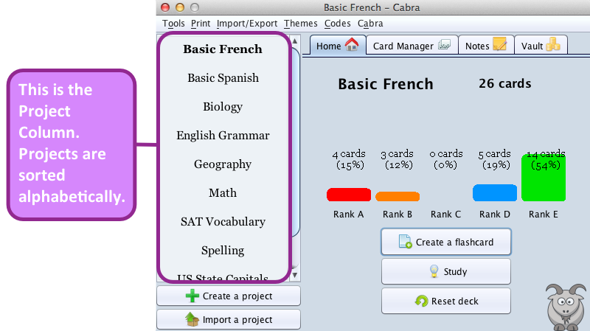

To open an existing project
To open an existing project, double-click on the project name in the Project Column. You can also right-click on the project name in the Project Column and click Activate project.

To change the project’s font and size
You can change the font and font size to suit your needs.

- From the Menu Bar, click Tools > Settings > Font.
- Select a Font Size.
- Select a Font Name.
- Click the X in the top corner to close the Settings window.

To rename a project
You can change the name of a project at any time.

- Right-click on the project name in the Project Column.
- Click Rename project.
- Type the new name.
- Click OK.

To delete a project
If you’re finished studying a subject, you can delete the project and its flashcards.

If you delete a project, this action is permanent. The data, including all flashcards, study session results, and project notes, cannot be recovered.

- Right-click on the project name in the Project Column.
- Click Delete project.
- Click Yes.

Importing and exporting a project
If you’re studying for a common subject such as U.S. capitals or Spanish vocabulary, you’ll find pre-made projects available on the Cabra Share Web page located at http://cabra.hathix.com/share.php. It may be quicker to import these pre-made projects instead of having to create your own from scratch. If you’ve created a project that you want to upload to the Cabra Share page, you can easily export your own projects.

To download a project from hathix.com
You’ll find several pre-made projects on a variety of topics available on hathix.com.

- Visit the Cabra Share Web page at http://cabra.hathix.com/share.php.
- Click the green arrow image next to the project you want to download.
- Click Download the file.
- Save the .cproj file to your computer. You can now import the project into Cabra.

To import a project
After you’ve downloaded a project from hathix.com, you’re ready to import it into Cabra.

- From the Menu Bar, click Import/Export > Import a project or click Import a project
- Navigate to the location on your computer where you saved the .cproj file.
- Click Open.

To export a project
If you want to share a project you’ve created, you can export it from Cabra and upload it to hathix.com.

- From the Menu Bar, click Import/Export > Export a project or right-click on the project name in the Project Column and click Export project.
- Select the project you want to export.
- Click OK.
- Select the folder on your computer where you want to save the .cproj file.
- Click Select.
- Click OK. You can now upload the project to hathix.com.

To upload a project to hathix.com
After you’ve exported a project from Cabra, you’re ready to upload it to hathix.com.

Projects uploaded to hathix.com are publicly available. Make sure you don’t upload any private information.

- Visit the Cabra Share Web page at http://cabra.hathix.com/share.php.
- Scroll to the bottom of the page.
- Click Choose File.
- Navigate to the location on your computer where you saved the .cproj file you want to upload.
- Select the .cproj file to upload.
- Click OK.
- Enter your name, tags, and a description of your project.
- Click Upload.

Creating, editing, or deleting a project note
You can use project notes to keep track of important information, things to remember, images that will help you when studying, and more. Notes are also a good way to add details about your project or to track your progress as you study. For example, if you’ve been studying for a test, after you take the test you can record your grade in a project note.

To create a project note
You can create a project note at any time. It can include any information that you think is relevant to the project, including pictures.

- Double-click on a project in the Project Column.
- Click Notes on the Project Tabs.
- Click the Note icon to create a note.
- Type the name of the note.
- Click OK.
- Type the note into the window.
- Click Save.

To change note font styles and colors
There are a variety of ways you can change the font styles and colors to match your mood. By clicking on Font, Size, or Color, you can experiment with what you want. To bold, italicize, or underline, choose the corresponding letter a at the bottom left of the Notes window.

To add a picture to a note
Pictures can help jog your memory so you’ll be able to remember details more easily.

- Click the Picture icon at the bottom right of the Notes window.
- Select a picture from your computer hard drive.
- Click Attach.

To delete a project note
If you no longer need a project note, you can delete it at any time.

If you delete a project note, this action is permanent. The data cannot be recovered.

In the Notes window, select the note you want to delete and click Delete.

Managing Flashcards

What are flashcards?
Flashcards are cards printed with words, numbers, or pictures that are used to help you study for a test or assignment. A deck of flashcards consists of a collection that is focused on one subject. There is no limit to the amount of flashcards you can create.

Creating flashcards

To create a flashcard
You can create as many flashcards as needed for each project. You can add flashcards at any time.

- Double-click on the appropriate project in the Project Column.
- Click Create a flashcard.
The Flashcard Creation window opens (Figure 4).

Figure 4: Flashcard Creation Window
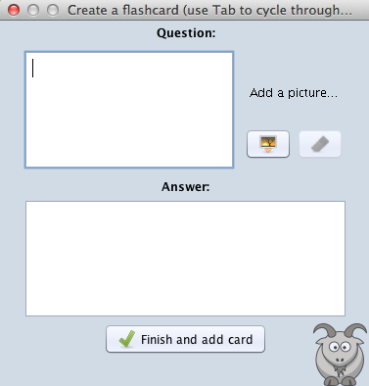

- Type the question or word in the Question field.
- Type the answer in the Answer field.
- If you want to attach a picture, click the Picture icon.
  - Select a picture from your computer hard drive.
  - Click Attach.
  - To delete a picture, click the Eraser icon.
You can’t add or delete pictures after you click Finish and add card, so please make sure you are satisfied with your picture choice at this point.

- Click Finish and add card.

To close the Flashcard Creation window
Click the X in the top corner to close the Flashcard Creation window.

Using the Card Manager
The Card Manager (Figure 5) is an organizer that lets you edit or delete flashcard questions and answers. You can also use the Card Manager to review all of your flashcards without starting a study session. Flashcards are displayed in the order in which you entered them.

Figure 5: Card Manager
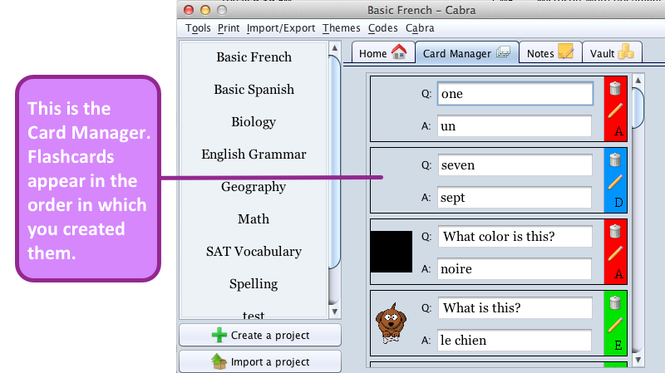

To edit a flashcard
You can edit a flashcard to update a question or answer, fix a typo, or add more information.

- Double-click on the appropriate project in the Project Column.
- Click Card Manager on the Project Tabs.
- Click the Pencil icon next to the flashcard you want to edit.
- Make the necessary edits.
- Click the Save icon.

You can’t add or edit a picture using the Card Manager. You will need to create a new flashcard instead. See Creating flashcards.

To delete a flashcard
If you’re finished studying a flashcard, you can delete it at any time.

If you delete a flashcard, this action is permanent. The data cannot be recovered.

- Double-click on the appropriate project in the Project Column.
- Click Card Manager on the Project Tabs.
- Click the Trash icon next to the flashcard you want to delete.
- Click Yes.

Studying with Flashcards

What is a study session?
After you’ve created your flashcards, you’re ready to start a study session. During a study session, you’ll be shown flashcards and asked to type the correct answer. The correct answer will then be displayed, and you can choose whether you got the answer right, wrong, or sort of right. Cabra’s study sessions are personalized based on how many answers you get right and how many you get wrong. You’ll spend more time studying the flashcards that you get wrong, which means you won’t waste time studying the questions you already know.

To start a study session
After you’ve created at least one flashcard, you can start a study session.

- Double-click on the appropriate project in the Project Column.
- Click Study.
The Study Session window opens.

- Click Start a new study session.
- Type an answer in the Answer field.
- Click Show answer.
- Click either Got it, Sort of, or Nope to indicate if you answered correctly.

To skip a flashcard
During a study session, click the Skip icon at the top of the Study Session window.

To quit a study session
You can quit a study session at any time, even in the middle of the session.

- During a study session, click the Quit icon at the top of the Study Session window.
- Click Yes.

To change the number of flashcards shown during each study session
The default number of flashcards per study session is 50. You can reduce or increase the number of flashcards in increments of 10.

- From the Menu Bar, click Tools > Settings > Studying.
- Use the arrows to select the number of flashcards.
- Click the X in the top corner to close the Settings window.

Understanding your Study Session Results

About your Study Session Results
The Study Session Results window (Figure 6) shows you exactly how well you did during the most recent study session. You can see how many answers you got right, how many you got wrong, and how many you sort of knew. You’ll also see a percentage of how well you did out of 100%. At the bottom of the window, there is a graphical representation of how well you did. You can quickly tell by the amount of green, yellow, or red whether you need to study again.

Click Start a new studying session to begin a new study session.

Figure 6: Study Session Results Window
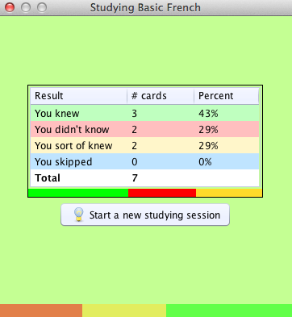

To close the Study Session Results window
Click the X in the top corner to close the Study Session Results window.

Earning a higher project rank
The more you study, the higher your project rank. When you earn a higher project rank, you can earn more points to redeem for prize packs. See Earning points for more information.

Resetting the deck
Resetting the deck of flashcards will clear all previous study session data. The program will function as though you have never used this deck of flashcards to study.

Resetting a deck causes your project rank to revert to Rank A. This can affect the amount of points you earn when you complete a study session. See Earning points for more information.

To reset the deck of flashcards
When you reset the deck, Cabra will treat the next study session as if you are studying for the first time. This means that you’ll see each flashcard during your next session, regardless of whether or not you answered it correctly in the past.

- Double-click on the appropriate project in the Project Column.
- Click Reset deck.
- Click Yes.

Studying with printed flashcards

To print flashcards
You can print flashcards so you can study with a friend, share flashcards, or have your mom or dad quiz you.

- From the Menu Bar, click Print > Print flashcards.
- Select the project you want to print.
- Click OK.

Your computer’s Print window will open. Follow the prompts to print the flashcards.

To prepare printed flashcards
Printed flashcards can be prepared quickly. You just need a pair of scissors.

- Cut the printed flashcards along the lines indicated (Figure 7 on page 21).
- Fold the flashcards in half so that the question is on one side and the answer is on the other.

Some questions may also include pictures. If so, remember to fold the question and picture so they are displayed on the same side of the paper.

Figure 7: Printed Flashcards
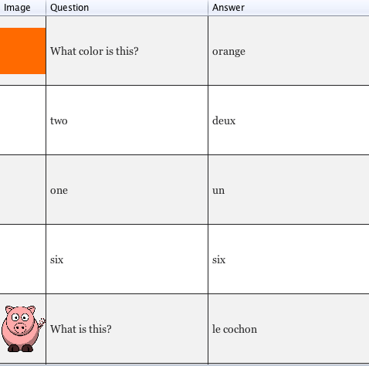

Personalizing Cabra

Why personalize Cabra?
Studying for a test may not be the most exciting activity in the world, but you can make it more interesting by giving it some personality. Cabra lets you change program colors and earn points to purchase prize packs—all of which helps make studying more fun.

Themes
Cabra includes over a dozen themes, so there’s sure to be something that matches your studying mood. You can even let the program choose a random theme or random colors for you.

To change the theme
You can change Cabra’s theme at any time. Match the theme to your mood that day!

- From the Menu Bar, click Themes.
- Select one of the available themes, or click Random Theme or Random Color.

Earning points
Points allow you to purchase prize packs. The more activities you do in Cabra, the more points you can earn. The more points you earn, the more prize packs you can buy! Sometimes you’ll even be rewarded just for opening the program.

Try to earn enough points to collect matching prize packs. And be on the lookout for the uncommon prize packs! Earning points is just one more way that Cabra helps keep you interested in studying.

To earn points
You can earn points for just about any activity you do in Cabra.

- Click Vault on the Project Tabs.
- Click How to earn points (Figure 8 on page 23).

Figure 8: How to Earn Points
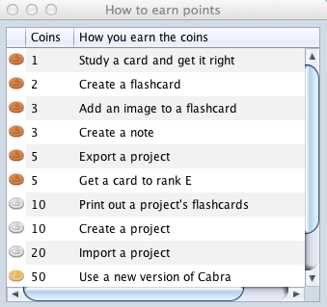

To redeem a code
You can enter a code to earn points. You’ll receive a code the first time you open Cabra after installation.

- Click Codes > Enter a code.
- Type in the code.
- Click OK.

You can find a code on the Cabra website at http://cabra.hathix.com. You just have to search for it! You might also receive codes randomly as you use the program.

To view a redeemed code
Keep track of the codes you’ve redeemed in the past.

- Click Codes > Codes redeemed.
- Click OK.

To purchase prize packs
When you earn points, you can buy prize packs with those points. The more you buy, the more interesting and uncommon prize packs you’ll see.

- Click Vault on the Project Tabs.
- Click Store.
- Click Buy pack next to the prize you want to purchase.
- Click Yes.
- View your prize pack.
- Click the X in the top corner to close the Prize Pack window.

To view your vault
The vault is where you can view all of the prize packs you’ve purchased.

- Click Vault on the Project Tabs.
- Click Vault (Figure 9).
Figure 9: Vault
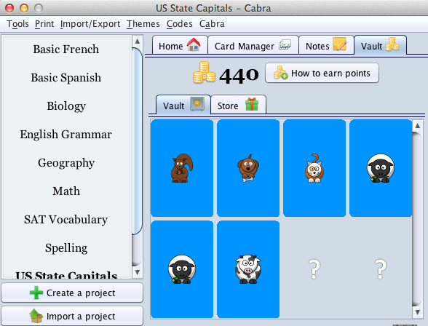

Troubleshooting

Common problems
Problem | Solution
Point totals do not update. | Exit Cabra and restart the program.
Cabra crashes when opening. | Clear program data.

To clear program data

If you clear the program data, you will lose all of your Cabra data for every project, flashcard, and study session. It cannot be recovered.

- From the Menu Bar, click Tools > Clear data.
- Click Yes.

Technical support
Visit the Cabra website at http://cabra.hathix.com for help, downloadable projects, and more. You can also email neel@hathix.com for technical support.

Appendix

Keyboard shortcuts
Key Combination | Shortcut To
Alt + o | Tools menu
Alt + p | Print menu
Alt + i | Import/Export menu
Alt + t | Themes menu
Alt + c | Codes menu
Alt + a | Cabra menu
Command + q | Exit Cabra (Mac only)

Index

About Cabra, 7
Appendix, 26
Card Manager, 5, 16, 17
Clear program data, 25
Codes
Redeem a code, 23
View redeemed codes, 23
Computer requirements, 6
Earning points, 22
Features, 7
Flashcards, 15, 18
Create a flashcard, 15
Delete a flashcard, 17
Edit a flashcard, 16
Managing flashcards, 15
Printed flashcards, 20
Printing flashcards, 20
Font, 11
Installing Cabra, 8
Java Runtime Environment, 6
Keyboard shortcuts, 26
Notes, 13
Customize fonts and colors, 13
Delete a note, 14
Personalizing Cabra, 22
Themes, 22
Prize packs, 23
Program updates, 8
Project, 10
Create a new project, 10
Delete a project, 11
Download a project, 12
Export, 12
Import, 12
Load projects from a new folder, 10
Open an existing project, 11
Project rank, 19
Rename a project, 11
Stored location, 10
Upload a project, 12
Project Column, 11, 12, 13
Resetting the deck, 19
Studying, 18
Quit a study session, 18
Reset the deck, 20
Skip a flashcard, 18
Start a study session, 18
Study Session Results, 19
Technical support, 25
Themes, 22
Troubleshooting, 25
Uninstalling Cabra, 9
Vault, 22, 23, 24

